LGE VC [OEM name] [Project name]

SW Architectural Design

Notice:
Information contained in this document is classified LG Confidential Proprietary. No person outside the LG Group shall have access to the information contained in this document unless business needs dictate, otherwise. It is the responsibility of the person knowing the information contained in this document to ensure confidentiality of information contained in it and securing unauthorized access to this document at all times.

About This Template
- Document Title: Software Architeacutral Design Template

Version | Date | Comment | Author
2.5 | 2016-May-30 | Initial Release | VC SW Capability Enhancement Team | Eunyoung Koh  (ey.koh@lge.com)

Read me first
- This template guides how to develop Software Architectural Design (SAD) document with the green-colored guideline and example.
- Ground Rule, Document Format, Document Versioning, and File Naming Rule are covered at General Guidelines below.
- Green-colored guidelines should be removed after document is finished.
- This template cannot fit every need or project 100%. Project-optimized tailoring is allowed depending on the scope or characteristics of each project.
- Definitions of terms used in this document
  - SW Element: The software is decomposed into elements of the software architecture across appropriate hierarchical levels down to the software components (the lowest level elements of the software architecture). (source: A-SPICE)
  - SW Component: The lowest level of element, which is a unit of SW Detailed Design.
  - SW Unit: The smallest SW Component that cannot be divided into more.

General Guidelines !! You should not miss these.
- Ground Rule on SAD Writing
- In SAD, at least one or more SW components should be identified through architectural design. SDD will be documented by component for detatiled design.
- Rationales for the architectural desicisions should be fully represented.
- Describe quality requirement scenarios measurably in quantitative way. Also, these requirements should be applied when designing architecture.
- Any kind of design tools can be used for SAD. This template uses EA for diagrams.

- Seven Rules for Sound Documentation (Source: Documenting Software Architecture - Second edition)
- Documentation should be written from the point of view of the reader, not the writer.
- Avoid unnecessary repetition.
- Avoid ambiguity.
- Use a standard organization.
- Record rationale.
- Keep documentation current but not too current.
- Review documentation for fitness of purpose.

- References
- Automotive_SPICE_PAM_v3.0 (SWE.2)
- Software Architecture in Practice, Third Edition
- Documenting Software Architectures : Views and Beyond, Second Edition
- IEEE 1471-2000, IEEE Recommended Practice for Architectural Description for Software-Intensive Systems
- IVI template that has been used previously

- Document Format
These are general rules for document format, which are applied to this template.
- Text Font: Arial
- Figures and tables have captions to find and check them easily.
- Create Caption: [References] > [Insert Caption] > [Label] > Select [Figure] or [Table].
- Put the figure caption under the figure. Figure 1 Title, Figure 2 Title,..
- Put the table caption above the table. Table 1 Title, Table 2 Title,..

- Document Versioning, File Naming Rule
Follow the “Document Output Naming Rule” from “LGE_IVI_Guideline_Configuration Management”

About This Document
Document Information
Issuing authority | Department that owns the document (Example: IVI CID Dev Team)
Configuration ID | CMBook’s CI ID
Status of document | Select among In Progress / Approved / Released

Revision History
Sort the revision history from newest to oldest.

Verion | Date | Comment | Author | Approver
#.# | YYYY-MM-DD | OOOOOOOOOOOOOOO | OOO | OOO
1.1 | 2016-02-20 | Modified xxx notation of C&C Diagram in 2.2 C&C View. | Gildong Hong | Sam Shin
1.0 | 2016-01-20 | Initial Release | Gildong Hong | Sam Shin

Purpose
Describe the purpose of this document.

This document specifies the software architecture design for XXX to support Software Requirement. This design document also serves as a guideline on how each software components in the system should be implemented and how the components should interact with each other.

Scope
Describe the scope of this document.

- Architectural Drivers
- SW Architectural Representations
- Resource Consumption Objectives
- Interface Design
- Architectural Alternatives
- Quality Attribute Scenarios

Audience
Describe the audience of this document.

The target audience of this document is :

- Requirement engineer who will point out any contradiction between the design and the requirement
- Software architect who will evaluate the design of the software
- Component developer who will implement the design in actual code
- Application developers who need to interact with [SW Name]
- XXX project participants who want to understand the architecture of the [SW Name]
- Test engineers who verify [SW Name] and others related

Related Documents
Describe the related documents of this document including title and version.

- IHU_MAIN SRS (Software Requirement Specification)
- IHU_MAIN SDD (Software Detailed Design)

Conventions
This document remarks “NOTE” as follows.

NOTE
To describe information that helps audience’s conveniences.

Acronyms / Glossary
Describe the acronym and its description, which should be alphabetized.

Acronym | Description
C&C View | Component-and-Connector View
IHU | IVI Head Unit
SAD | Software Architecture Design
SDD | Software Detailed Design

Table of Contents
This template can update Table of Contents automatically. Mouse over the below table > Right-click > [Field Update].
1 Architectural Drivers 9
1.1 SW Main Features 9
1.2 Quality Attributes 10
1.3 Constraints 11
1.3.1 Business Constraints 11
1.3.2 Technical Constraints 11
2 SW Architectural Representations 12
2.1 Static View 12
2.1.1 SW Component Descriptions 13
2.2 Dynamic View 14
2.2.1 Task Design 15
2.2.1.1 Task Structure 15
2.2.1.2 Task Scheduling 16
2.3 Deployment View 17
3 Resource Consumption Objectives 18
4 Interface Design 19
4.1 SW Component Interface Table 19
5 Architectural Alternatives 20
5.1 Architectural Design 1 [Example: Native implementation of XXX core function] 20
5.2 Architectural Design 2 20
6 Quality Attribute Scenarios (Optional) 21
6.1 Scenario N : Quality Attribute [Example: Scenario #1 : Performance] 21
6.2 Scenario N : Quality Attribute 22

Figures
This template can update Figures automatically. Mouse over the below table > Right-click > [Field Update].

Figure 1 Module View 12
Figure 2 C&C View 14
Figure 3 C&C View for Task Scheduling 16
Figure 4 Deployment View 17

Tables
This template can update Tables automatically. Mouse over the below table > Right-click > [Field Update].

Table 1 Software Main Features 1 9
Table 2 Software Main Features 2 9
Table 3 Quality Attribute Requirements 10
Table 4 Business Constraints 11
Table 5 Technical Constraints 11
Table 6 SW Component Descriptions 13
Table 7 Task Structure 15
Table 8 Resource Comsumption Objectives 18
Table 9 SW Component Interface Table 19
Table 10 Concerns for Design Alternatives 20
Table 11 Scenario Refinement for Scenario #1 21

Architectural Drivers

Architectural drivers are a set of requirements that have significant influence over your architecture and performance/quality. In this chapter, describe software main features, quality attributes, and constraints on the basis of SRS.

SW Main Features
- (Mandatory) Describe main features of the software to implement in following format.
- (Optional) It is allowed to copy contents from SRS in order to keep consistency.

Example 1
Table 1 Software Main Features 1
Level 1 | Level 2 | Level 3 | Descriptions
IHU_MAIN | Application Manager | Application Lifecycle Management | - Operates application such as resuming app, pausing app and launching app.  - Manages application state: applications can have states such as launched, paused, etc.
IHU_MAIN | Application Manager | Application Information | …
IHU_MAIN | Application Manager | … | …
IHU_MAIN | Application Launcher | Boot Startup Management | - Decides the boot startup sequence based on various factors including the last used application.  - Delivers the LUC information to Applicatio when starting the Application
IHU_MAIN | Application Launcher | Application Monitor | …
IHU_MAIN | Application Launcher | … | …
IHU_MAIN | AppCommon API | Client API | - Registers application for communication  - Event Notification to and from applications

Example 2
Table 2 Software Main Features 2
Level 1 | Level 2 | Level 3 | Level 4 | Descriptions
Multimedia | Audio Player | Disc Audio Player |  | Plays music that is stored in disc (CD, MP3, DVD).
Multimedia | Audio Player | USB Audio Player |  | Plays music that is stored in USB.
Telematics | Telephony | Call | Voice Call Request | Requests voice call connection to the given number.
Telematics | Telephony | Call | Voice Call Answer | Answers the incoming voice call.
Telematics | Telephony | Call | … | …
Telematics | Telephony | Remote Vehicle Control | Remote Door Lock | Remote door lock.
Telematics | Telephony | Remote Vehicle Control | … | …

Quality Attributes
- (Mandatory) Describe scenarios for each quality requirement specified in SRS.
- (Mandatory) Scenarios should be described measurably in quantitative way.
- (Optional) At Chapter 6 Quality Attribute Scenarios, refine high-priority scenarios.

Scenario # | Scenario | Quality Attribute | SRS ID | Priority
Scenario number: It will be used to identify scenarios in Chapter 6. | Describe scenarios for quality attributes measurably in quantitative way. If quality attributes are described in SRS, you can copy them here. | Related quality attribute | Related SRS ID | Priority specified in SRS

Table 3 Quality Attribute Requirements
Scenario # | Scenario | Quality Attribute | SRS ID | Priority
1 | The IVS shall generate an eCall within 1 second after the confirmed triggering signal is received. | Performance | QA1_1 | High
2 | … | … |  | …
3 | … | … |  | …
4 | … | … |  | …

Constraints
(Mandatory) Describe constraints from business and technical perspectives.

Business Constraints
ID | Business Constraint | SRS ID
Business constraint ID | Describe constraints from business perspective.  If business constraints are described in SRS, you can copy them here. | Related SRS ID

Table 4 Business Constraints
ID | Business Constraint | SRS ID
BC1 | Deploy the architecture system in 10 weeks.
BC2 | ...

Technical Constraints
ID | Technical Constraint | SRS ID
Techincal constraint ID | Describe constraints from technical perspective.  If technical constraints are described in SRS, you can copy them here. | Related SRS ID

Table 5 Technical Constraints
ID | Scenario | SRS ID
TC1 | The system consists of a head office server located at the head office, and the POS terminals placed at store cashiers
TC2 | ...

SW Architectural Representations

- Define the software architecture in module, C&C, and deployment viewtypes required for different perspectives of various stakeholders.
- The main purpose of software architectural representations is to identify components consisting the the software.

Static View
- (Mandatory) Define the software architecture of target software in module viewtype.
- (Mandatory) At Section 2.1.1 SW Component Descriptions, you need to describe components identified below.

This is the software architectural design of OOO. OOO consists of Remote Trip Statistics, Remote Battery Charge, Remote Honk&Flash, ….

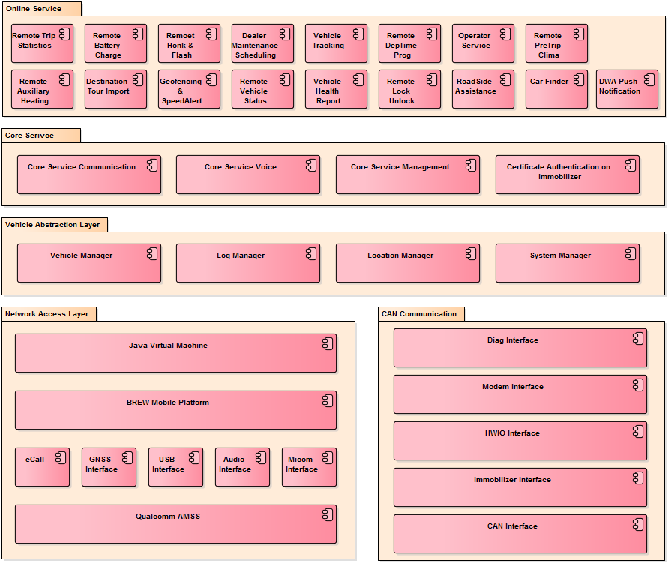
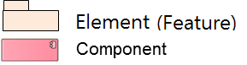
Figure 1 Module View

SW Component Descriptions
- (Mandatory) Describe all components which have been identified at Section 2.1 Static View. For each component, related SRS IDs should be specified.
- Depending on the software size and characteristic, components may not be classified as features.
- If SRS has a large amount of requirements, it is more efficient to manage traceability in a separate excel file.
- (Optional) If you will reuse or buy a component, add a column and indicate whether the component is reusable or buyable.

Feature | SW Component ID | SW Component Name | Description | SRS ID
Feature name | Component ID | Component name | Describe the component. | Related SRS ID

Below table describes the software components which are speicified in the chapter 2.1.

Table 6 SW Component Descriptions
Feature | SW Component ID | SW Component Name | Description | SRS ID
Online Service | XXX_SWC-001 | Remote Trip Statistics | Vehicle’s trip information (mileage, average consumption) | SRS-XXX_100
Online Service | XXX_SWC-002 | Remote Battery Charge | To control e-vehicle’s battery charging function remotely | SRS-XXX_101

Dynamic View
- (Mandatory) Define the software architecture in Component & Connector viewtype to describe connection relations and communication mechanisms between components. Component in C&C view means principal processing units and data stores.
- In C&C view, component types are client, server, filter, object, and DB.
- (Mandatory) At Chapter 4 Interface Design, you need to describe all interfaces identified below.

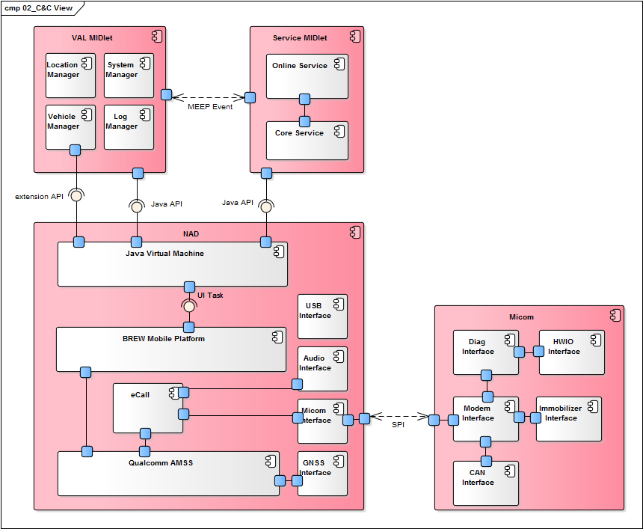
Figure 2 C&C View

This diagram mainly represents components consisting the OCU architecture and interfaces connecting between components.
- Service MIDlet consists of Java Online service and Java Core service, and it uses Java standard API.
- …
- …
- …

Task Design
- (Mandatory) Identify tasks to be executed during runtime, define the structure of tasks, and describe related components and functions. Run units such as processes and threads are called task.
- As run unit depends on the environment such as OS and development languages, tasks should be designed according the execution environment. Depending on the development environment like BSP, OS, or AUTOSAR platform, task types and constraints may change.

This chapter describes the tasks that the IHU_MAIN module requires. The task is the runtime unit that executes a job periodically or event-basis. The task is represented as process, thread, etc.

Task Structure
Task ID | Task Name | Description | SW Component Name | Constraints
Task ID | Task name | Describe the responsibility of the task | Component name | Generally, following items are described for constraints.  - Cycle time  - Processing time  - Memory usage (heap, stack size)  Properties defined for a task in code or configuration file are described here usually. e.g. priority, cycle time, and memory size

The task may have constrains that the maximum cycle time, etc. that needs to be described in the below table.

Table 7 Task Structure
Task ID | Task Name | Description | SW Component Name | Constraints
IHU_MAIN_SWT_001 | AppManager Process | This task runs as a process, and receives requests for resuming and pausing Applications. | AppManager | Cycle time: n/a (request basis processing)  Processing time: Maximum startup time to start last audio/video source is 10 seconds.
IHU_MAIN_SWT_001 | AppLauncher Process | … | … | ...

Task Scheduling
Describe the task scheduling result by considering the task execution time, order, and cycle. Check that if there is no problem for synchronizing tasks and executing a task within max processing time.

When the IHU_MAIN module is executed at the startup of IHU System, AppManager and AppLauncher are executed as separate processes. They load AppCommon library to communicate with other entities (e.g., AppManager and AppLauncher use AppCommon library to communicate).
AppManager manages the lifecycle of Applications such as resuming and pausing them. Application may be the native Application written with QT, or the Web Application. The runtime view for AppManager is shown in the following figure:
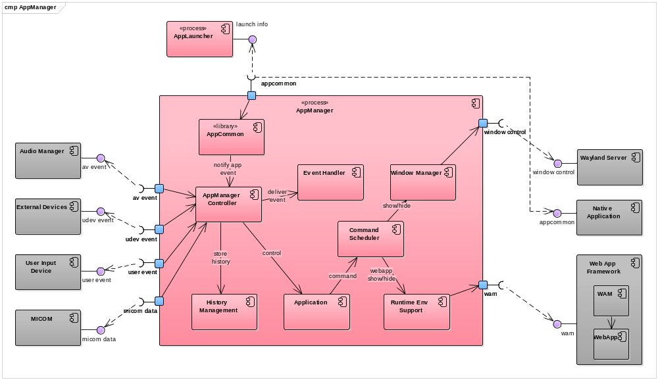
Figure 3 C&C View for Task Scheduling

Deployment View
(Mandatory) Define the software architecture representing relations between softwares and hardwares consisting the system, on the basis of C&C view defined at Section 2.2 Dynamic View. Describe main considerations if needed.

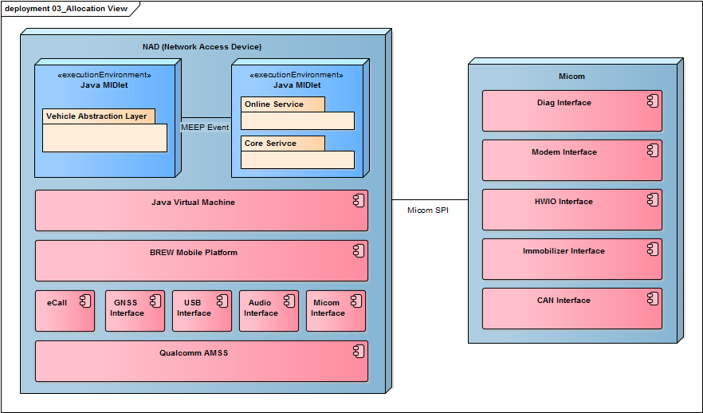
Figure 4 Deployment View

Resource Consumption Objectives

(Mandatory) Describe resource consumption for resources like CPU, runtime memory, and ROM memory for all software components which have been identified at Section 2.1.1.

Feature | SW Component Name | CPU Load | CPU Load | Runtime Memory | ROM Size | Remarks
Feature name | Component name | CPU load of the component (%) | CPU load of the element (%) | Runtime memory size of the element | ROM size of the element | Remarks

Below table shows the estimated CPU load, runtime memory and rom memory for each software components.

Table 8 Resource Comsumption Objectives
Feature | SW Component ID | SW Component Name | CPU Load | CPU Load | Runtime Memory | ROM Size | Remarks
Online Service | XXX_SWC-001 | Remote Trip Statistics | 15% | 30% | OO MB | OO MB
Online Service | XXX_SWC-002 | Remote Battery Charge | … | 30% | OO MB | OO MB
Online Service |  | … | … | 30% | OO MB | OO MB
 |  |  | 3% | 40% | OO MB | OO MB
 |  |  | … | 40% | OO MB | OO MB
 |  |  | … | 40% | OO MB | OO MB
 |  |  | … | 40% | OO MB | OO MB
 |  |  | … | 40% | OO MB | OO MB
 |  |  | … | 40% | OO MB | OO MB
 |  |  | 10% | 70% | OO KB | OO KB
 |  |  | … | 70% | OO KB | OO KB
 |  |  | … | 70% | OO KB | OO KB
 |  |  | … | 70% | OO KB | OO KB
 |  |  | … | 70% | OO KB | OO KB

Interface Design

Describe all interfaces which have been idenfified at Section 2.2 Dynamic View.

SW Component Interface Table
(Mandatory) Define interfaces for each SW component.

SW Component Name | Interface Name | Type | Parameters
Component name | Interface name | Choose among types below. (Can be added)  - call: Call local function.  - dbus: Communicate with dbus.  - LIN: | Input/output parameters

This section specifies the interface related to Application Launcher.

Table 9 SW Component Interface Table
SW Component Name | Interface Name | Type | Parameters
Application Loader | MakeLaunchAppList | call | In:  - context data: LUC, country information, car variant  Out:  - Boot sequence list: list in which order the Application shall be started
Application Loader | … | … | …
Application Loader | … | … | …
AppProcess | launch | call | N/A
AppProcess | checkRestart | call | In:  - Restart count: the restart number until now
AppProcess | … | … | …
Logger | log | call | In:  - Data: data to be logged

Architectural Alternatives

(Mandatory) Evaluate alternative software architectures and describe rationales for the chosen software architecture.

Architectural Design 1 [Example: Native implementation of XXX core function]
The following core functions of XXX need to be implemented using native because starting XXX should not be effected by any architecture related to JavaVM or abstraction. (from customer requirement ID XX, XX)

- …
- …
- …

For this, design alternatives are considered with the following concerns:

Table 10 Concerns for Design Alternatives
ID | Concerns | Alternative #1:  using Java XXX | Alternative #2:  using native XXX
AD_1 | Reduce time to market for future enhancements | Yes | No
AD_2 | Reduce costs | Yes | No
AD_3 | Reduce risks | No | Yes
AD_4 | System qualities | No | Yes
AD_5 | Reuse existing infrastructure | Yes | Unknown
AD_6 | Use proven technologies | Unknown | Yes
AD_7 | Performance | No | Yes

In terms of resuse or maintenance, it is advantageous to use Java, however, the core function of XXX is XXXX. Therefore, we decided to implement XXX in native application.

Architectural Design 2

Quality Attribute Scenarios (Optional)

(Optional) Select high-priority scenarios from Section 1.2 Quality Attributes and refine them.
By refinement, requirements can be changed into measurable quality attribute goals so that you can set strategies more easily when designing software architecture.

Scenario N : Quality Attribute [Example: Scenario #1 : Performance]
Refine each selected scenario according to the following format.

Scenario Refinement for Scenario N
Scenario |  | Quality requirement scenario
Scenario Components | Stimulus | A condition that requires a response when it arrives at a system
Scenario Components | Source of stimulus | Some entity (a human, a computer system, or any other actuator) that generated the stimulus
Scenario Components | Environment | Certain condition that occurs the stimulus
Scenario Components | Artifact (If known) | Some artifact (a collection of systems, whole system, or some piece) that is stimulated
Scenario Components | Response | Activity undertaken as the result of the arrival of the stimuls
Scenario Components | Response measure | Measurable response to make it testable
Architectural Decisions & Reasoning |  | Architectual decisions affecting quality attribute responses, rationales, and discussions
Risks |  | Anaylzed risks
Trade-off |  | Anaylzed trade-off as a result of architectural decision
Allocated SW Component |  | Allocated SW component name

Table 11 Scenario Refinement for Scenario #1
Scenario Refinement for Scenario #1
Scenario |  | The IVS shall generate an eCall within 1 sec after the confirmed triggering signal is received.
Scenario Components | Stimulus | Airbag deployment signal / Emergency call button pressed
Scenario Components | Source of Stimulus | Airbag or Button
Scenario Components | Environment | Car accident or emergency situation
Scenario Components | Artifact (If Known)
Scenario Components | Response | Trigger eCall after receiving the airbag or button signal.
Scenario Components | Response Measure | Generate eCall within 1 sec after receiving the signal.
Architectural Elements |  | eCall / CAN Interface / HWIO Interface / Modem Interface / Micom Interface / Audio Interface
Architectural Decisions & Reasoning |  | Time required for communicating between Micom and NAD using SPI → Airbag crash signal is set to high priority.  Time required for communicating with MIB to secure audio path → If there is no response from MIB within OOO seconds, set HW mute and change to use local loud speaker.
Risks |  | 1) Low priority services may be blocked  2) If converting to local loud speaker gets delayed, eCall sound may not be heard properly.
Trade-off |  | None
Allocated SW Component |  | OOO

Scenario N : Quality Attribute

-The End-

